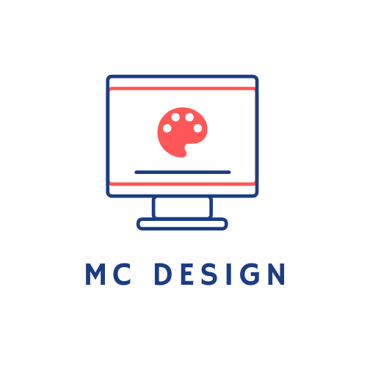

Planning and Preparation

Allan Foddering

Middlesbrough College

20/01/2019

Contents

Introduction 5

1.0 Website Design Principles 6

1.1 Website Usability Design 7

2.0 Website Map 9

2.1 Navigation Chart 9

2.2 Moodboard 10

2.3 Wireframes 11

2.4 Storyboard 12

2.5 File Structure 13

3.0 Sample Images 14

3.1 Logo 14

3.2 Social Media Icons 15

3.3 Resizing Event Images 15

3.4 Saving the Images 15

Conclusion 16

Figure List 17

Figure 1 – Homepage of shortiedesigns.com 17

Figure 2 – Homepage of lingscars.com 17

Figure 3 – Mobile homepage of shortiedesigns.com 18

Figure 4 – Testing lingscars.com load time 18

Figure 5 – Testing shortiedesigns.com load time 19

Figure 6 – Pricing page of shortiedesigns.com 19

Figure 7 – Portfolio page of shortiedesigns.com 20

Figure 8 – Contact page of shortiedesigns.com 20

Figure 9 – Quote page of shortiedesigns.com 21

Figure 10 – Price page of lingscars.com 21

Figure 11 – Blog page of lingscars.com 22

Figure 12 – BMW 1 Series page of lingscars.com 22

Figure 13 – Mobile homepage of lingscars.com 23

Figure 14 – Quote page 2 of shortiedesigns.com 23

Figure 15 – Quote page 3 of shortiedesigns.com 24

Figure 16 – Quote page 4 of shortiedesigns.com 24

Figure 17 – Browser Users in 2019 25

Figure 18 – Navigation Chart for The Bridge website 25

Figure 19 – Moodboard for the Bridge website 26

Figure 20 – Wireframe for the Bridge (Desktop View) 26

Figure 21 – Wireframe for the Bridge (Tablet View) 27

Figure 22 – Wireframe for the Bridge (Mobile View) 28

Figure 23 – Storyboard for the Bridge Homepage 29

Figure 24 – Storyboard for the Bridge Events page 30

Figure 25 – Storyboard for the Bridge Find Us page 31

Figure 26 – the Bridge folder structure 32

Figure 27 – Tyne Bridge opened in Adobe Illustrator 32

Figure 28 – Image before tracing and expansion 33

Figure 29 – Image after tracing and expansion 33

Figure 30 – Adding text to the logo 33

Figure 31 – Changing the artboard size 34

Figure 32 – Removing the background 35

Figure 33 – The finished logo 35

Figure 34 – Exporting the logo 36

Figure 35 – Tracing and expanding the image 36

Figure 36 – Deleting the background 37

Figure 37 – Recolouring the logo 37

Figure 38 – The finished recolour 38

Figure 39 – The largest image on the first row of the events page 38

Figure 40 – Checking the canvas size 39

Figure 41 – Changing the canvas size 39

Figure 42 – Saving the image as a .png 40

Figure 43 – The images saved in the file structure 40

Reference List 41

# Introduction

A music venue in Newcastle named the Bridge have asked for a website to be designed. In this report we will explain what elements make up good web design and using this research we will then apply this to the design of a website for them. Finally, in preparation for the build phase of the site, we will create a range of sample images.

# Website Design Principles

Before presenting a design, we must first analyse what good design looks like and we’ll do this with shortiedesigns.com (figure 1). As a contrast, we’ll look at lingscars.com (figure 2) which is not as well designed.

The first thing you’ll notice about shortie designs is the homepage is simple. There are only 11 elements on the page, and less in mobile view (figure 3). This is important so the purpose is obvious, it ensures easy navigation, and it ensures the website is quick to load (1.6s – see figure 4). Ling’s cars however is much more busy. This makes the purpose obscure, it can be difficult to navigate, and the website loads slowly (10s – see figure 5). (Astra, 2018) (uptrends.com, 2020)

Ensuring the consistency of your design is also important. In figures 1 and 6 – 9 we can see that Shortie Designs use the same colours throughout, the same fonts, and the same layouts. When looking at Ling’s cars however (figures 2 and 10-12) we can see that each page has different layouts, fonts and colours – especially the blog page (figure 11). Consistency is important to ensuring your website has a sense of identity which will ensure it is memorable. (Digital Marketing Blog, 2019) (Lacey Tech Solutions, 2013)

Choosing the right colours can also sway the opinions and actions of your users. Looking at our examples, we can see that Shortie Designs uses the same white background, with generally blue content which instils a sense of professionality. There is also a small amount of red which calls users to action, and it is only used on the quote button. When looking at Ling’s Cars, the colour is used indiscriminately. This promotes a feeling of confusion and unease that will put off potential customers. (Fabrikbrands.com, 2017) (Business Website Center, 2018)

Modern websites must also be responsive meaning they are adaptable to the size of the screen. This is important as users all work on different devices, and it must be consistent across all of them. To ensure a site is responsive a developer can, for example, change the layout, change the size of elements and increase the whitespaces. Considering consistency alongside responsiveness is also important, the site must be visually similar across all devices to ensure brand identity. Responsive website design is demonstrated well by Shortie Designs. Looking at figures 1 and 3 we can see that site is noticeably consistent across both views. We can see that the content has been moved about to fit on a small screen and that the text has been increased in size to make it easier to read. Ling’s cars on the other hand is not responsive – and on mobile we must scroll left to see other content. Some of the text is also very difficult to read on a smaller screen. (FreshSparks, 2019) (Digital Next, 2019)

# Website Usability Design

Designing a good-looking website is only half the battle. Ensuring the website is usable is also important. Steve Krug tells us that one of the most important parts of ensuring website usability is “don’t make me think” and by this he means that we should be able to use and navigate a website without asking ourselves any internal questions (e.g where is ___?). (Krug, 2014)

We’ve discussed how layout is important to design, but layout also contributes to the usability. Ensuring a good layout will mean that that less of those internal questions are asked. With Shortie Designs, we see and example of good layout – especially with the navigation bar where a user can instantly find what is required. In contrast with Ling’s website – this layout is entirely too busy and causes confusion for the user.

It is often said that web developers must follow the *three click rule* which is that content must be accessible in 3 clicks or less otherwise users will abandon the site. This theory however has come under much scrutiny recently, and in tests has been disproven. (Testing the Three-Click Rule, 2003) The important principle is the scent of information – ergo cues that convince the user they will find information. Examples on the shortie designs website are shown from when you first land on the homepage (with the red button) until you input your information (figure 16. There are subtle visual cues that to the user that information lies ahead. For Ling’s site however, there are no such cues and information must be hunted down in a sea of content, which likely causes more frustration than not being able to find the information in three clicks or less. (Optimizely.com, 2019) (Zoltan Gocza, Zoltan Kollin, 2019)

Colour also must be considered for usability not just design. For example, red text on a black background is awful to read (example) and indeed so is grey text on a white background (example). Some people also suffer from colour blindness which can make some colours hard to distinguish. Again, shortie designs have thought about this and have provided a colour scheme where the content is contrasted to the background whereas Ling has used an assortment of colours indiscriminately, making some content very difficult to absorb. (tictoc digital, 2017)

Returning to the idea of responsiveness, having a responsive site is important for usability also, as most people now browse the internet on their smartphones. In fact, websites are often designed mobile first. This means that if you do not have a site that is responsive and can be used on any size screen including mobile, then users are not going to leave frustrated and use a competitor. Furthermore, due to Google’s changes to the way their search engine works in 2015, if your site is not responsive and mobile friendly, it will be less likely to show up in search results. (Digital Next, 2019) (Xia, 2017)

Finally, in the same vain as responsiveness, to ensure that more users can access the site as intended, a site should be tested in a wide range of browsers and on a range of devices as browsers and devices can all interpret things differently. In figure 16 we can see that most people use chrome, however this still leaves 36.78% of people who do not. If a site only works on chrome, we are significantly reducing the number of people who can access it, and therefore, this may lead to a significant loss of profits. (StatCounter Global Stats, 2019) (TestLodge Blog, 2016)

# Website Map

In this section we will present the designs and the maps which will show how the website will look, feel and work.

# Navigation Chart

A navigation chart shows how the pages will be linked together. For this I have chosen to use the program draw.io which is an online application that allows users to easily create different types of charts. The chart below shows that from the home page you can access both the events page and the find us page. This is a very simple example, but in more complicated websites, a navigation chart can be an extremely useful visual to know what page needs to link to what.

As we can see from the chart (figure 18) navigation will be simple if this hierarchy is followed, and users will be able to access any page from any other page. Meaning that (although it has been disproven) we are following the 3 click rule.

# Moodboard

A moodboard gives an impression of how a website will look and feel. It gives an idea of the colours, the text and general overall theme of a site. In order to create one, Microsoft PowerPoint has been used. This program was chosen simply due to the fact it is very easy to manipulate images and add in basic elements such as shapes and text. It is also a widely available program and so the files should be accessible by anyone.

The moodboard created can be viewed under figure 19.

The Bridge is described as “*designed to appeal to a more sophisticated target audience*”, and so images have been chosen to represent this. The images have little colour which is in stark contrast to the blocks of other content. Colours have been chosen which complement each other well, and that also will be enough of a contrast to ensure usability. Red will be the main colour as this represents excitement, energy and passion, and is a colour often used in the entertainment industry (avoleoo, 2014). A Logo has been designed in the top left which is simple and sophisticated. The logo represents both the name of the venue but also the location (Newcastle – the bridge in question is the Tyne Bridge) and continues the use of red, which is the company’s brand. The font chosen for the content on the site is Segoe UI. This is a sans-serif font which is perfect for websites as it is easy to read and looks modern as opposed to serif fonts (e.g. times new roman) which have decorative ends to them. Serif fonts can be hard to read on websites when considering the mobile first approach. (freeCodeCamp.org, 2018)

# Wireframes

Wireframes are basic mock-ups which show how the website will be laid out, they do not show any specific content, just where content will be placed. For this task Mockflow has been chosen as it is a simple easy to use tool in which elements can be manipulated quickly to create professional looking UI mock-ups. There are 3 views to consider for layouts – mobile, tablet and desktop. Each view will have different requirements when it comes to layout, for example due to the smaller screen size, some elements in a mobile layout may have to be larger than a desktop layout.

See figure 20 – 22 for the wireframes. These are also attached to this document as image files.

The layout in desktop view has been designed to be as simple as possible. The navbar on the top is always visible and shows up consistently across all 3 pages so that users can get to information quickly. On the homepage the purpose of the website is made clear instantly with the first block of content on top of the image. Below that are 3 upcoming or popular events so that users have this before clicking into events. Following that is a user form which will allow a user to sign up for a mailing list. This form has been designed to be as simple as possible with only 3 fields so as not to put users off completing it. At the bottom of the page will be the social media links in a coloured footer found on the bottom of every page. These are out of the way so as not to force social media onto users which can be off-putting, however if someone is looking for these, it means they will scroll past the rest of the content, which may entice them into booking an event they spot. Having it appear on every page also ensures consistency and gently reinforces that the social media is available. The events page has again been designed to be simple, with the large attention-grabbing images that will be the feature of the page. Below each image is a title in bold, and some smaller text which will describe each event. Finally, on the find us page there will be a large interactive google map. This will be more useful than a standard map as it will not require detailed instructions on the website itself as google maps will handle this. This reduces the requirement for a large amount of text on the page and makes it easier for the user to find the Bridge.

Sizing the layout down to a tablet view will see little change, this is because the layout has been designed so simply and with a large amount of whitespace that by just eliminating a little of this whitespace, we can keep a very similar looking layout without too much change to the site but retaining its usability. The font sizes will most likely be sized up to ensure this.

Mobile layout will be where the most amount of change is seen, however it is still a consistent and similar layout. The navbar remains at the top (albeit with the text sized up) which is where it would be expected to be found. Whilst in desktop and tablet view the content may be in 3 columns however this is not conducive to a mobile environment. Therefore, the content will instead be displayed one after the other to maximise the size of the text and the images. The social media links will remain at the bottom of the page in a coloured footer to provide consistency.

# Storyboard

A storyboard is designed to be ‘pixel perfect’. This means that it will show the user exactly how the site will look when it is completed, however it does not have to contain all the content. Lorem Ipsum is often used in place of actual content, however the layout, the images and even some of the titles will be included. The storyboard has been created using Adobe XD which is software designed to allow the user to create and prototype user experiences. This makes it perfect for designing websites as there are tools which allow the easy manipulation of elements, such as setting colour themes that can easily be changed. Furthermore, it has a mode which allows you to link pages together and then preview the site, in this sense it is almost like viewing the finished site as you can click through all the links and experience exactly how navigation will work. The storyboards are attached alongside this file, however to ensure they are still available without Adobe XD, they have also been created as image files. These can be viewed under figures 23 – 25.

Beginning with the homepage, the purpose of the website is clearly understandable from the start. The large image of the guitar shows the user that this is a music related website even before any text is read. The image is black and white which fits the classy theme. In stark contrast to the black and white image comes the feature box in red which draws the user’s eye and introduces them to the bridge instantly explaining the full purpose of the site. Below that as per the wireframes is the 3 popular events. Images have been chosen that are again desaturated images that fit the classy theme and draw the attention of the user without commanding it and taking it away from the titles in red below each one. The blocks of text have been coloured in a contrasting colour to the background, but again, are not too bright that it is difficult to read in large amounts. For the mailing list, the box which will explain the benefits of the mailing list has been coloured red as we want emphasis on the benefits and not to be on the form itself. The submit button is also red to call the users to action. Finally, on the bottom of the page the social media footer has also been coloured red to continue the branding and to bring a little more colour to the site. On the events page, the colours chosen are the same as the popular events on the homepage to promote consistency, and the navbar and footers remain the same also to be consistent and continue the branding. The find-us page is also designed with the same header and footer with content in the centre. The text below the map is the same as that on the other two pages to ensure continuity.

# File Structure

The final part of the design to consider is the file structure. According to Mozilla (the developers of Firefox) the best structure is to have one folder that contains the pages of the site (the html files) and within that folder is subfolders that contain the images, CSS styles and the JavaScript (MDN Web Docs, 2019). See figure 26 for a diagram of how this will be organised. This file structure will ensure that all the files are organised and that it is easy to reference each file when building the site.

# Sample Images

Images make up a large part of the website designs, and often these images need to be manipulated in some manner. In this section we will describe the methods used to produce some of the images that will be used in the Bridge website.

# Logo

As part of the branding, a logo needed to be created, and the software chosen to do this was Adobe Illustrator (figure 27). This software is excellent for creating a variety of digital images including logos as it can be used to create vector artwork – meaning that the artwork created can be enlarged and reduced in size without sacrificing quality.

The first step to the logo is to take the image that will be used (the Tyne Bridge – figure 28) and turn this into a vector drawing (so that it can be resolution independent). To do this the image is traced, and then expanded. This splits the image down into many shapes (figure 29).

Now the image has been converted into a vector, we can then add the text (figure 30). To do this, the text tool in Illustrator is used. With this we can type out the words “The Bridge” and then change font size (in this case 48pt) change the font (Perpetua Titling MT was chosen to contrast with the sans serif font used on the rest of the page) and the colour can be chosen (Red to fit the rest of the branding).

To ensure the image isn’t going to take up too much space on the site, we need to eliminate some of the whitespace on the top and the bottom. To do this we edit the artboard and drag the edges down, so it is closer to the content (figure 31).

Finally, we need to remove the white background that was from the original image, this is done by ungrouping the image and then simply selecting and deleting the background (figure 32).

Figure 33 shows the finished logo.

The image is then saved as a .ai file in-case it requires further changes. These file types however will not be able to be added to the website as an image however – and so this means that it needs to be exported as a supported image type. For this we export it in Adobe Illustrator as a .png file and save this in the images file for later use (figure 34).

# Social Media Icons

The social media icons needed to be recoloured as they were originally black. To do this recolouring as we were dealing with logos, again Adobe Illustrator was used.

Once again, the images needed to be converted into vectors. The image was traced and expanded as per figure 35.

Following this, the white background was removed by ungrouping the vector, selecting the background pieces and deleting them (figure 36).

To recolour the image, the logo was selected and then filled white (figure 37).

The finished result is on figure 38.

Finally, the image was exported as a .png in the same manner as for the Bridge logo (figure 34).

This process was repeated for all 3 social media logos.

# Resizing Event Images

The event images chosen were all differing sizes, and so this means when they are placed into the site, they may arrange differently on the page. In order to prevent this, some of the images needed transparent whitespace adding so they would all line up. The easiest program to accomplish this in was photoshop.

The largest image on the first line of the events page was figure 39. This meant the other two images needed to be made up to the same dimensions as that one.

To find the dimensions therefore, the image was opened in photoshop and the canvas size checked (figure 40).

To ensure the other images were the same size, they were also opened in photoshop and the canvas size was changed to match that of the largest one (figure 41).

The image was then saved as a .png file so that it was a regular image file (figure 42).

This process was repeated until all the images were the same dimensions.

# Saving the Images

The images were saved in the images folder as described in the file structure section of the design (section 2.5) – see figure 43 for confirmation.

# Conclusion

Within this report we have explained exactly what good web design and web usability entails. We have then taken this research and applied it to the creation of a website map including a moodboard, storyboards, wireframes a nav chart and a file structure chart. Following this we have then created a range of sample images which can be used during the build phase of the website.

# Figure List

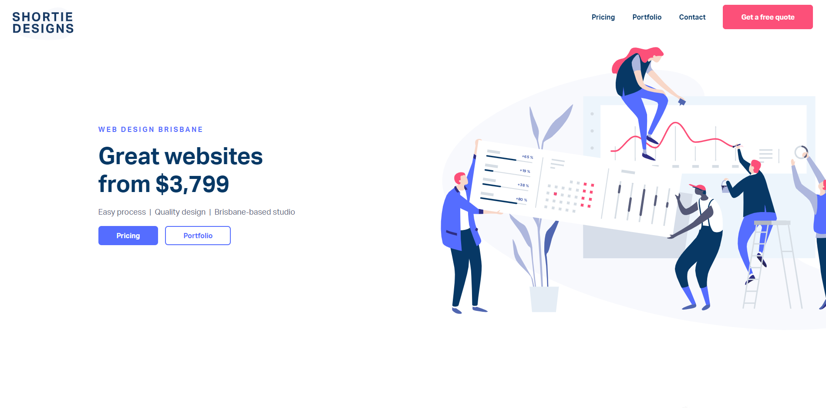

## Figure 1 – Homepage of shortiedesigns.com

(Shortie Designs, 2018) - Accessed 16 Jan 2020

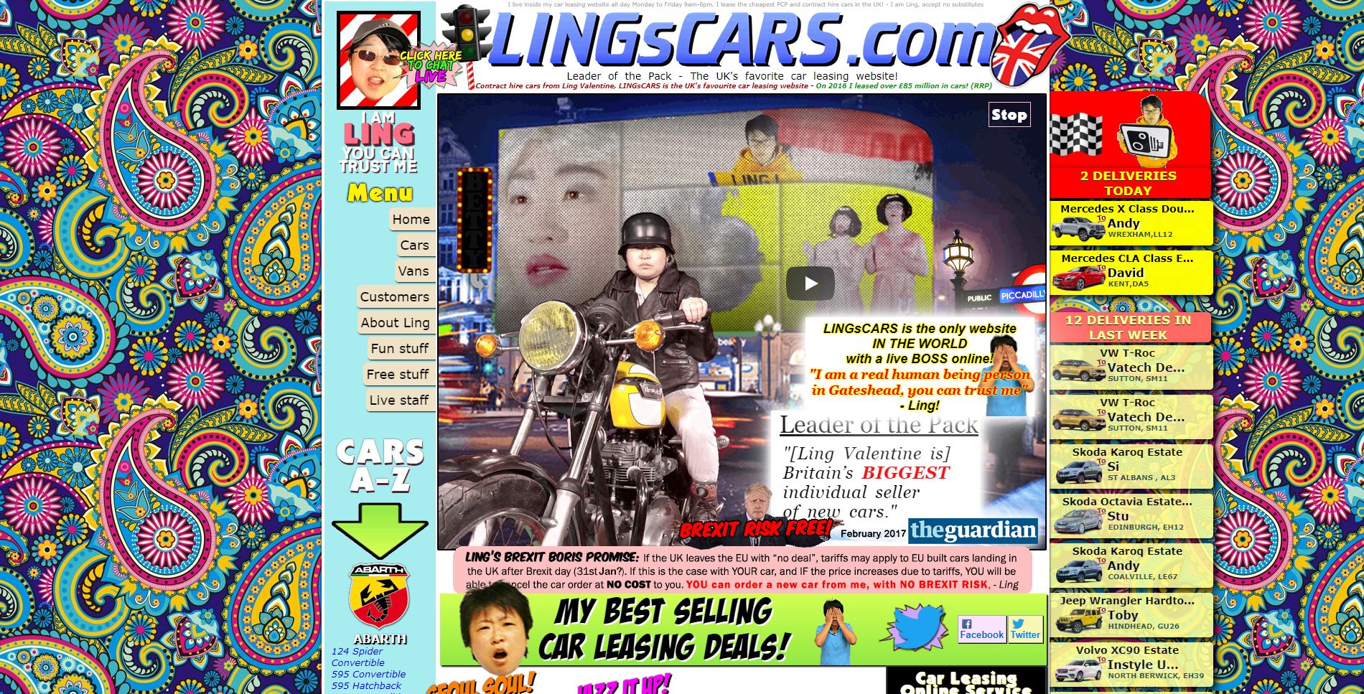

## Figure 2 – Homepage of lingscars.com

(Valentine, 2016) - Accessed 16 Jan 2020

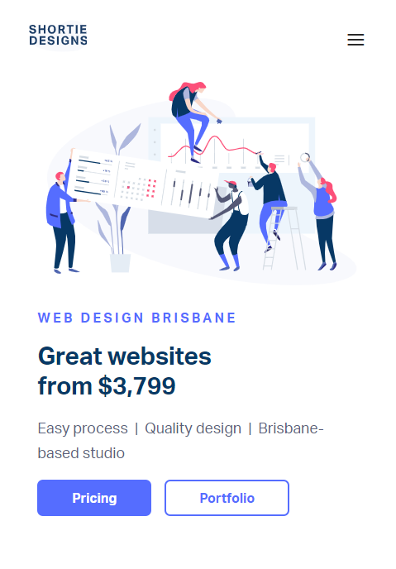

## Figure 3 – Mobile homepage of shortiedesigns.com

(Shortie Designs, 2018) - Accessed 16 Jan 2020

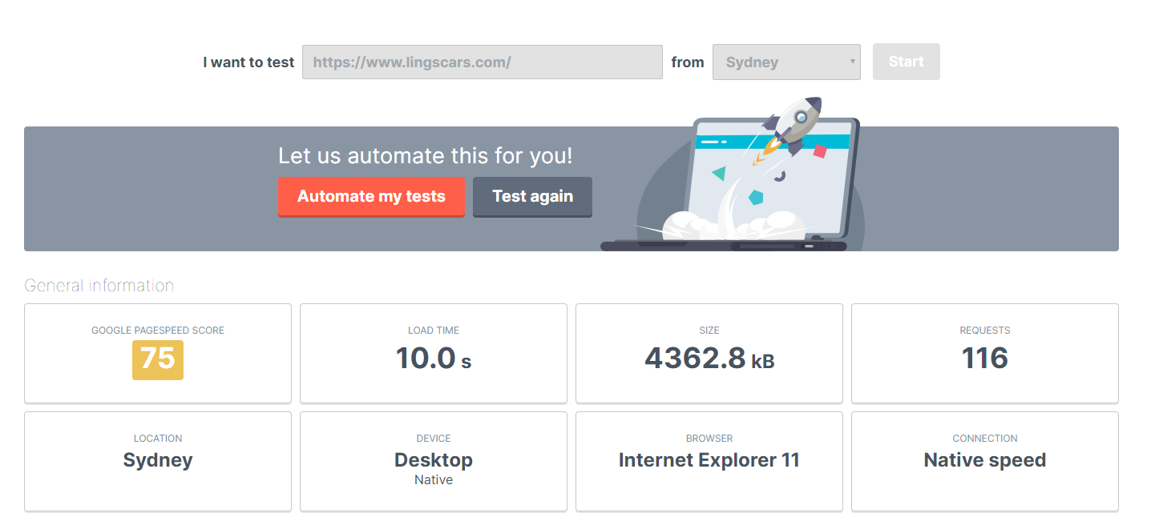

## Figure 4 – Testing lingscars.com load time

(Uptrends.com, 2020) – Accessed 16 Jan 2020

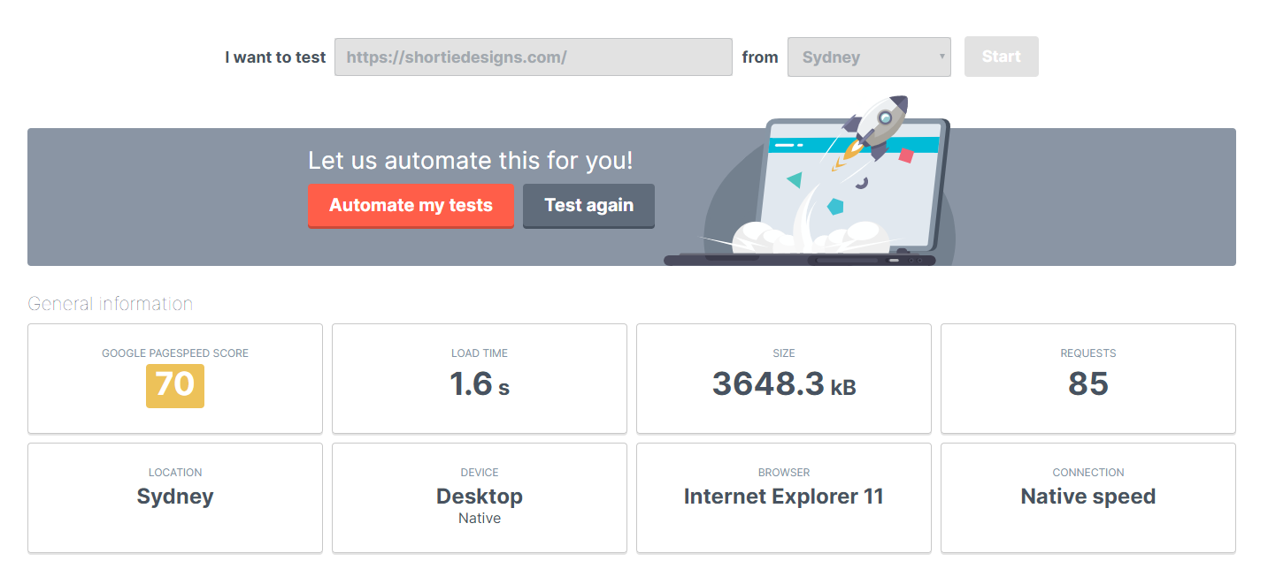

## Figure 5 – Testing shortiedesigns.com load time

(Uptrends.com, 2020) – Accessed 16 Jan 2020

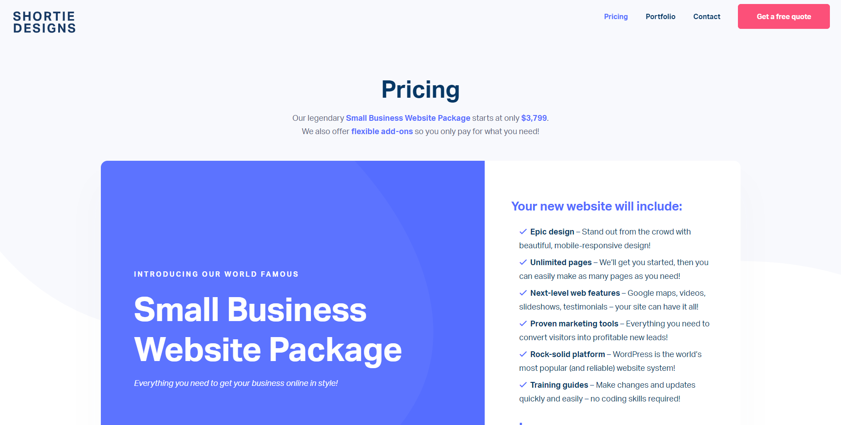

## Figure 6 – Pricing page of shortiedesigns.com

(Shortie Designs, 2018) - Accessed 16 Jan 2020

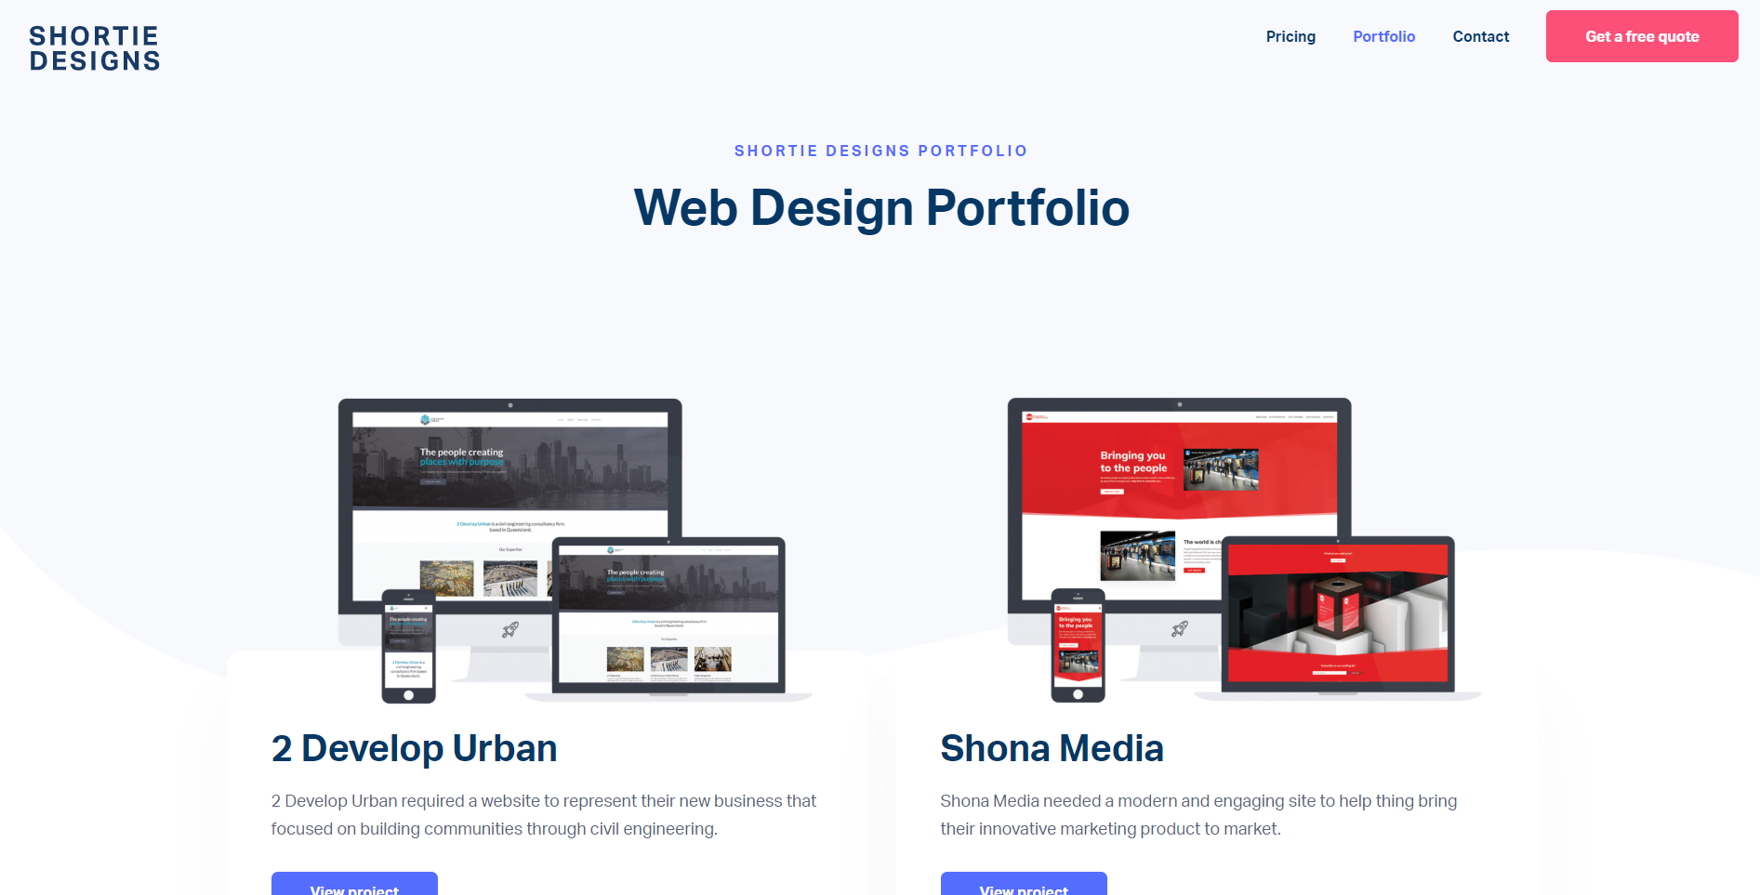

## Figure 7 – Portfolio page of shortiedesigns.com

(Shortie Designs, 2018) - Accessed 16 Jan 2020

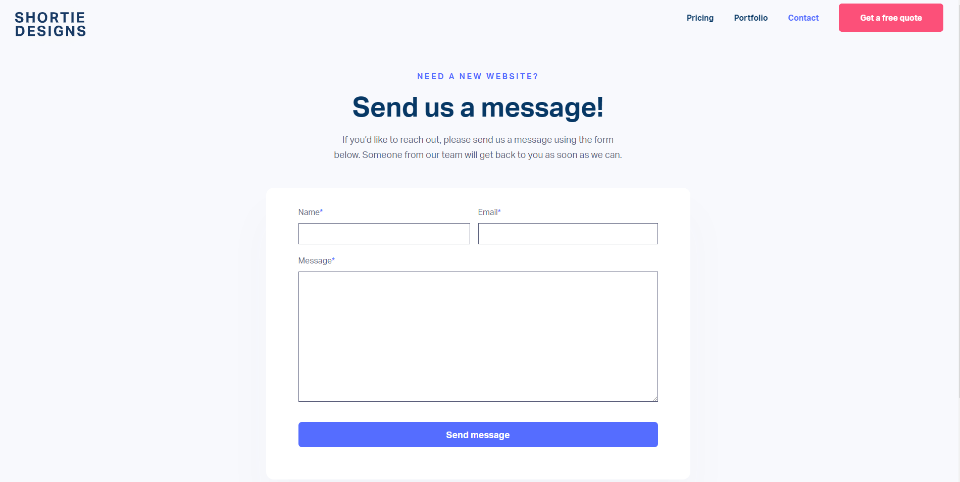

## Figure 8 – Contact page of shortiedesigns.com

(Shortie Designs, 2018) - Accessed 16 Jan 2020

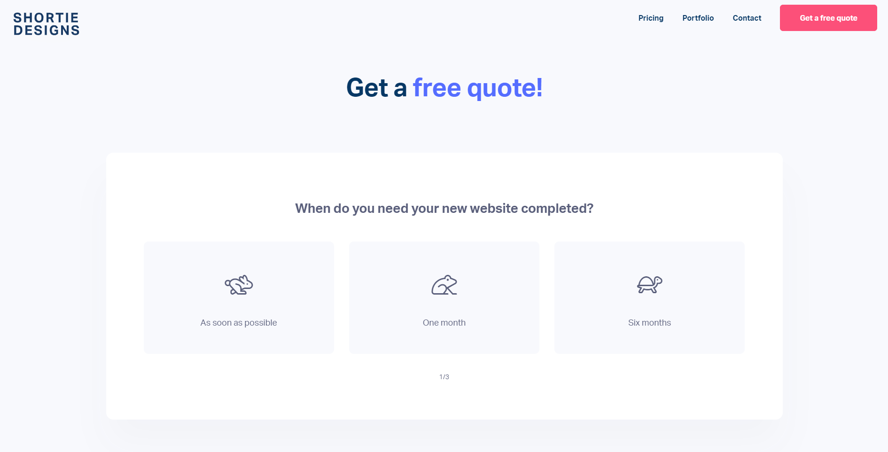

## Figure 9 – Quote page of shortiedesigns.com

(Shortie Designs, 2018) - Accessed 16 Jan 2020

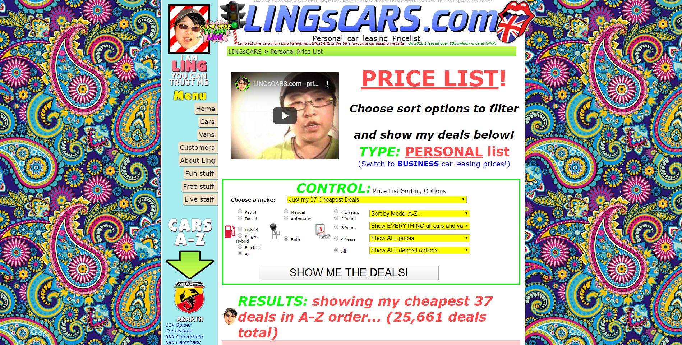

## Figure 10 – Price page of lingscars.com

(Valentine, 2016) - Accessed 16 Jan 2020

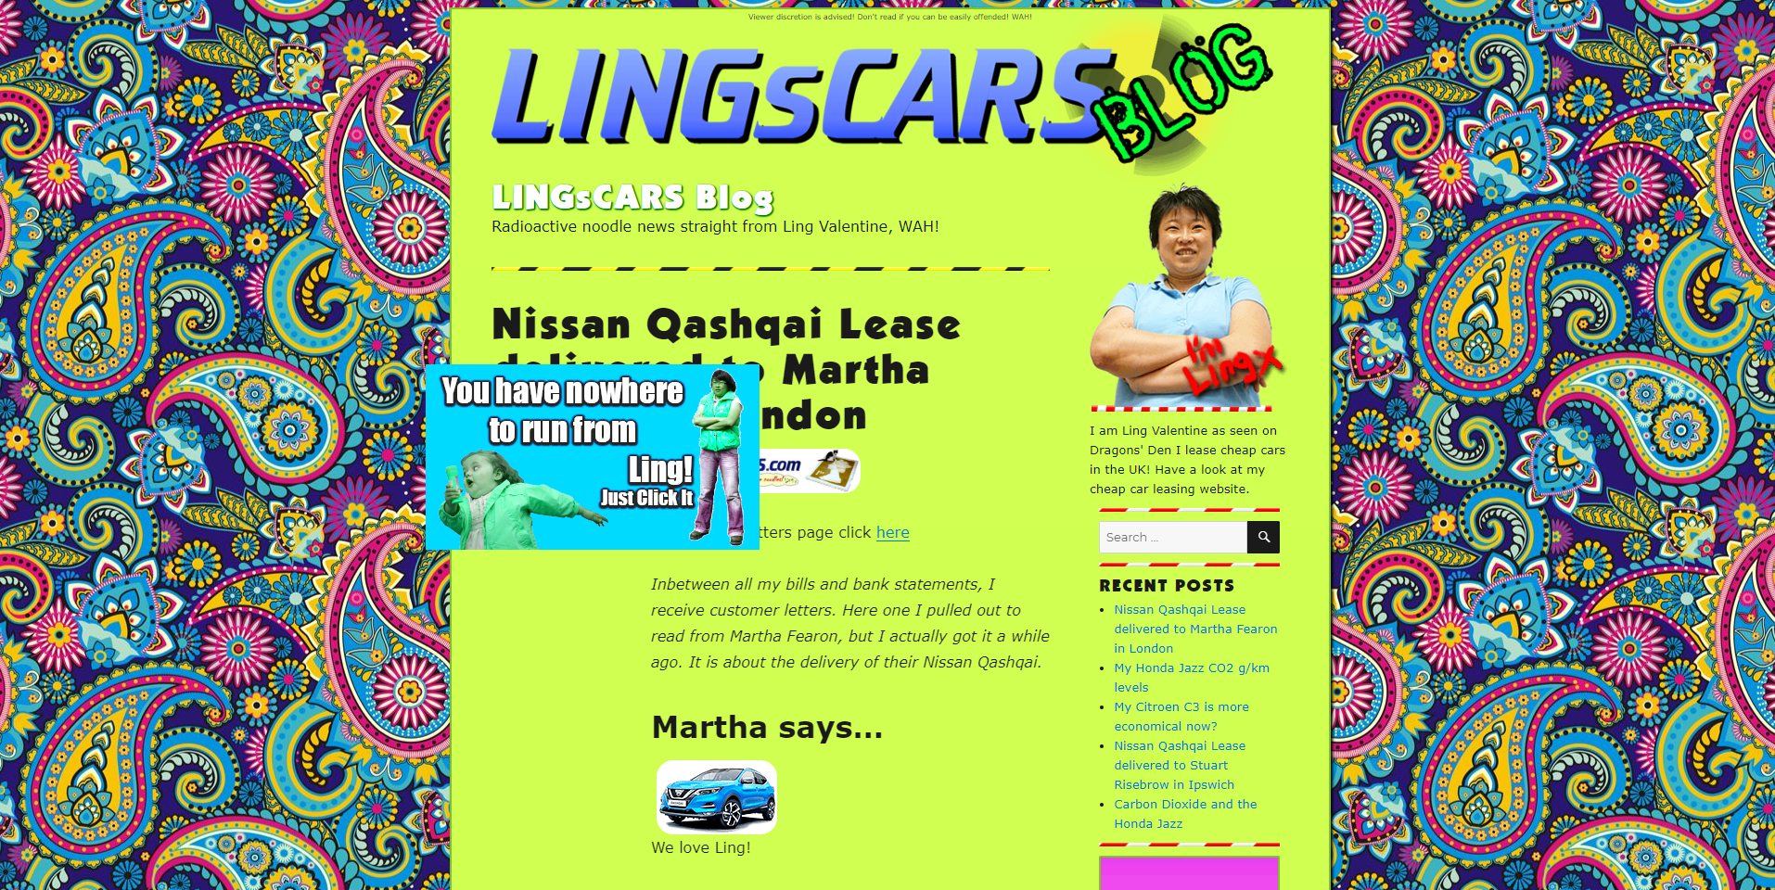

## Figure 11 – Blog page of lingscars.com

(Valentine, 2016) - Accessed 16 Jan 2020

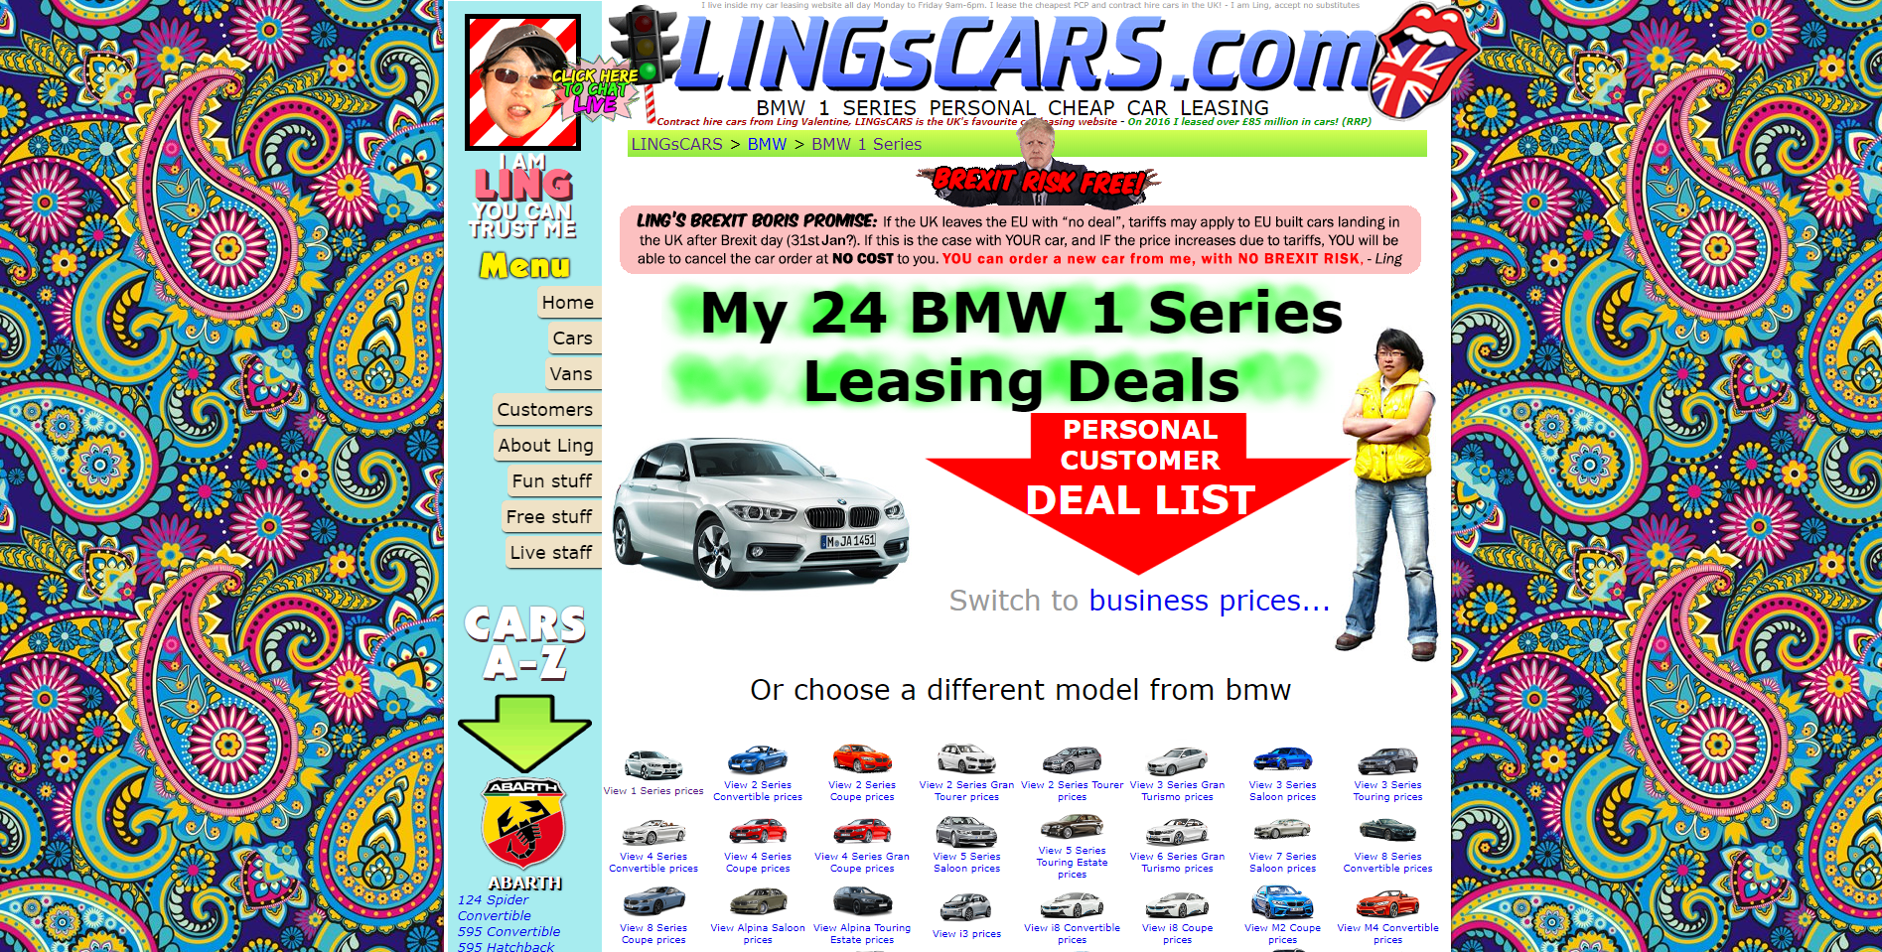

## Figure 12 – BMW 1 Series page of lingscars.com

(Valentine, 2016) - Accessed 16 Jan 2020

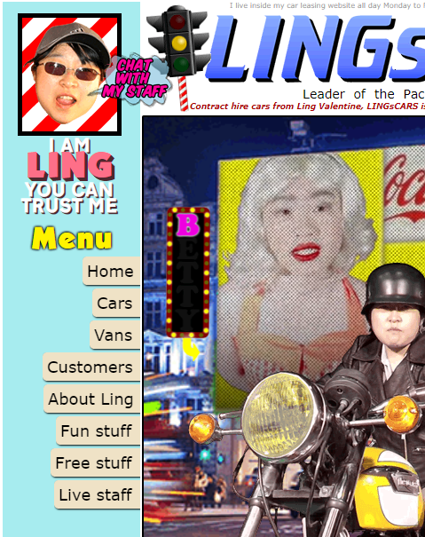

## Figure 13 – Mobile homepage of lingscars.com

(Valentine, 2016) - Accessed 17 Jan 2020

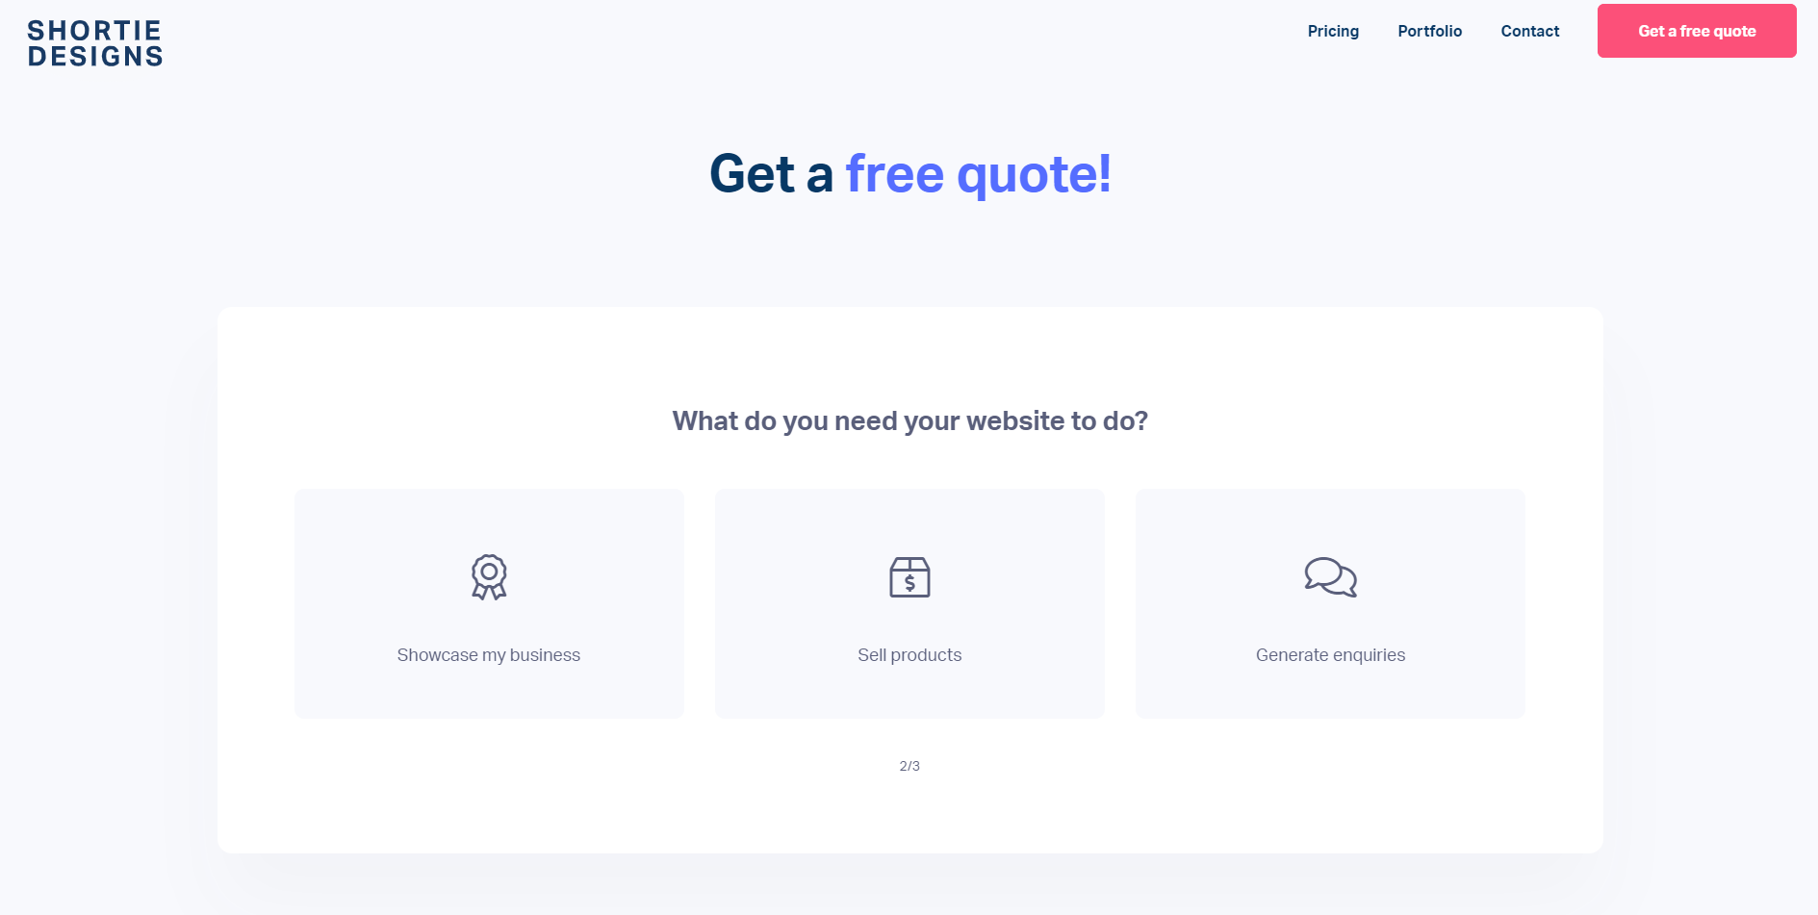

## Figure 14 – Quote page 2 of shortiedesigns.com

(Shortie Designs, 2018) - Accessed 17 Jan 2020

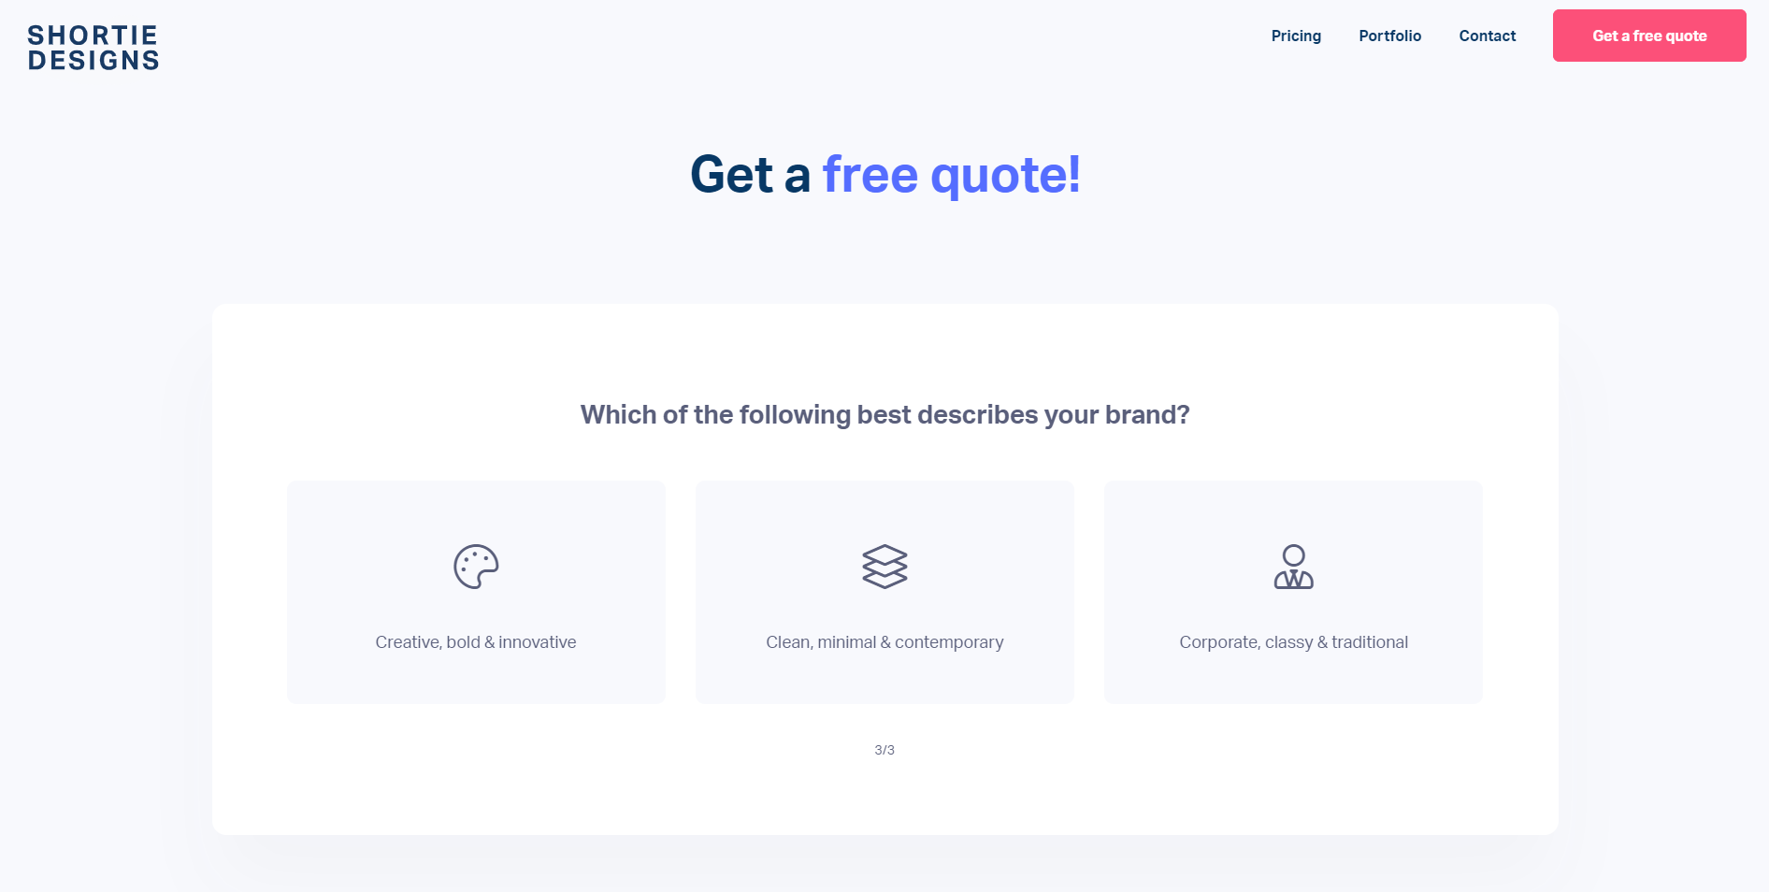

## Figure 15 – Quote page 3 of shortiedesigns.com

(Shortie Designs, 2018) - Accessed 17 Jan 2020

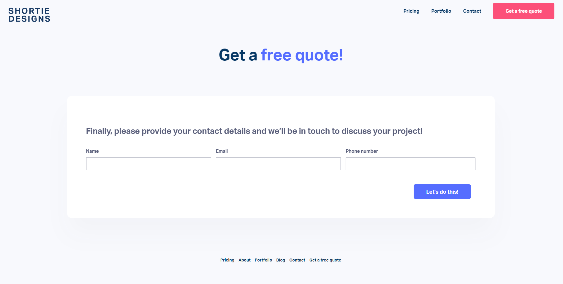

## Figure 16 – Quote page 4 of shortiedesigns.com

(Shortie Designs, 2018) - Accessed 17 Jan 2020

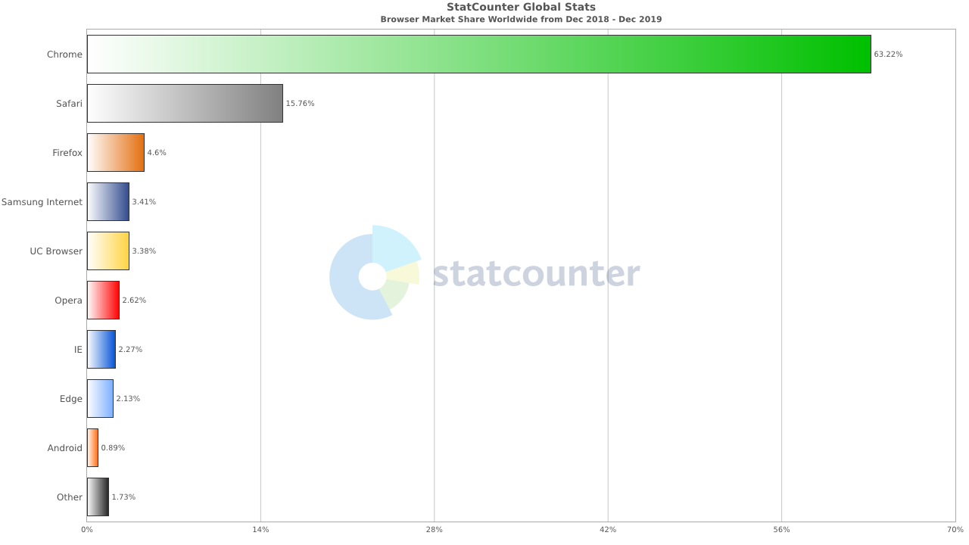

## Figure 17 – Browser Users in 2019

(StatCounter Global Stats, 2019)- Accessed 17 Jan 2020

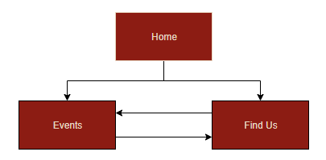

## Figure 18 – Navigation Chart for The Bridge website

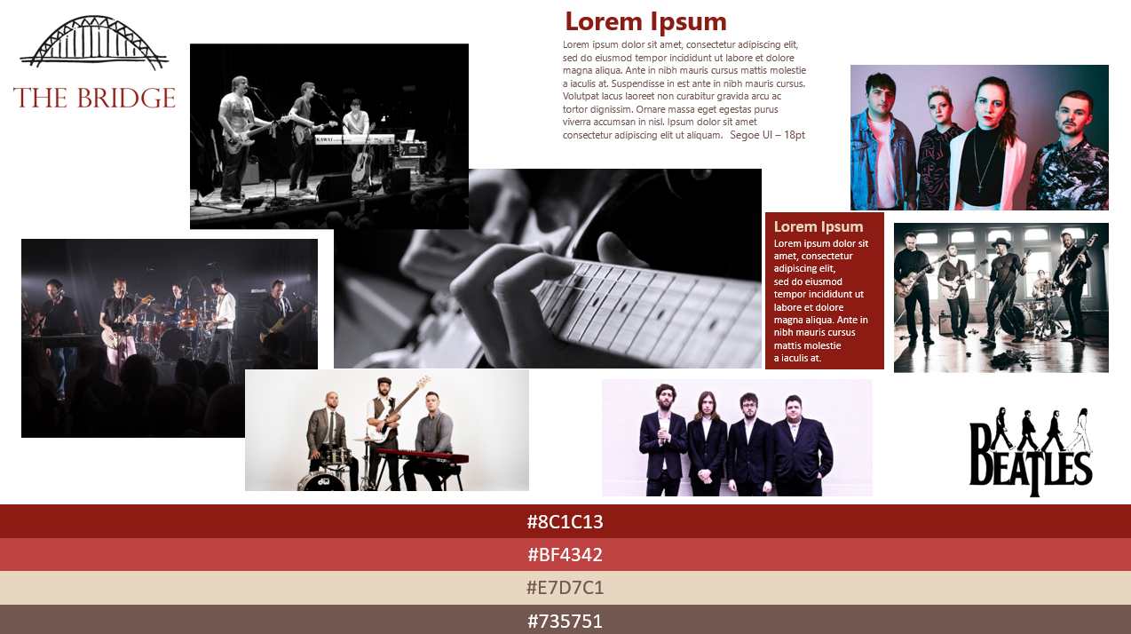

## Figure 19 – Moodboard for the Bridge website

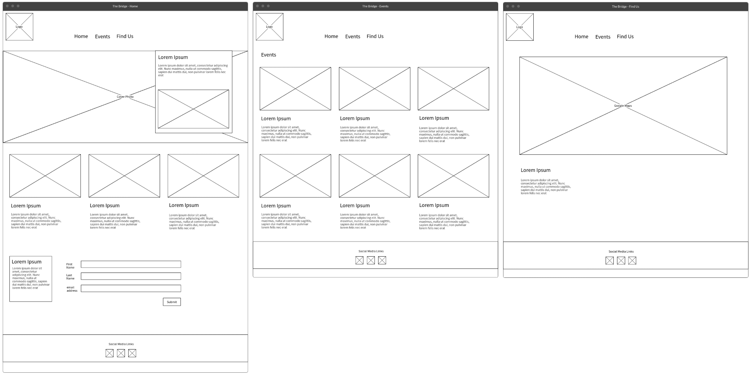

## Figure 20 – Wireframe for the Bridge (Desktop View)

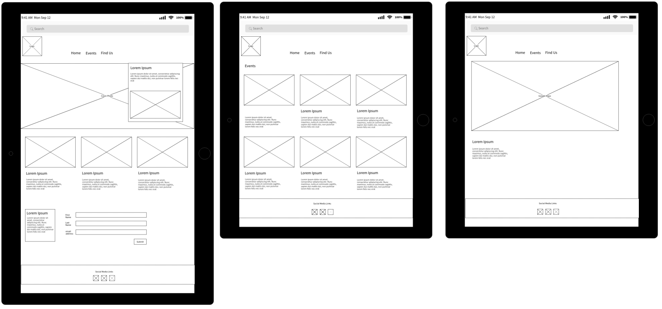

## Figure 21 – Wireframe for the Bridge (Tablet View)

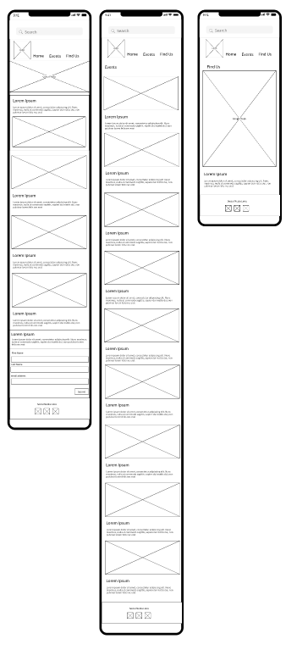

## Figure 22 – Wireframe for the Bridge (Mobile View)

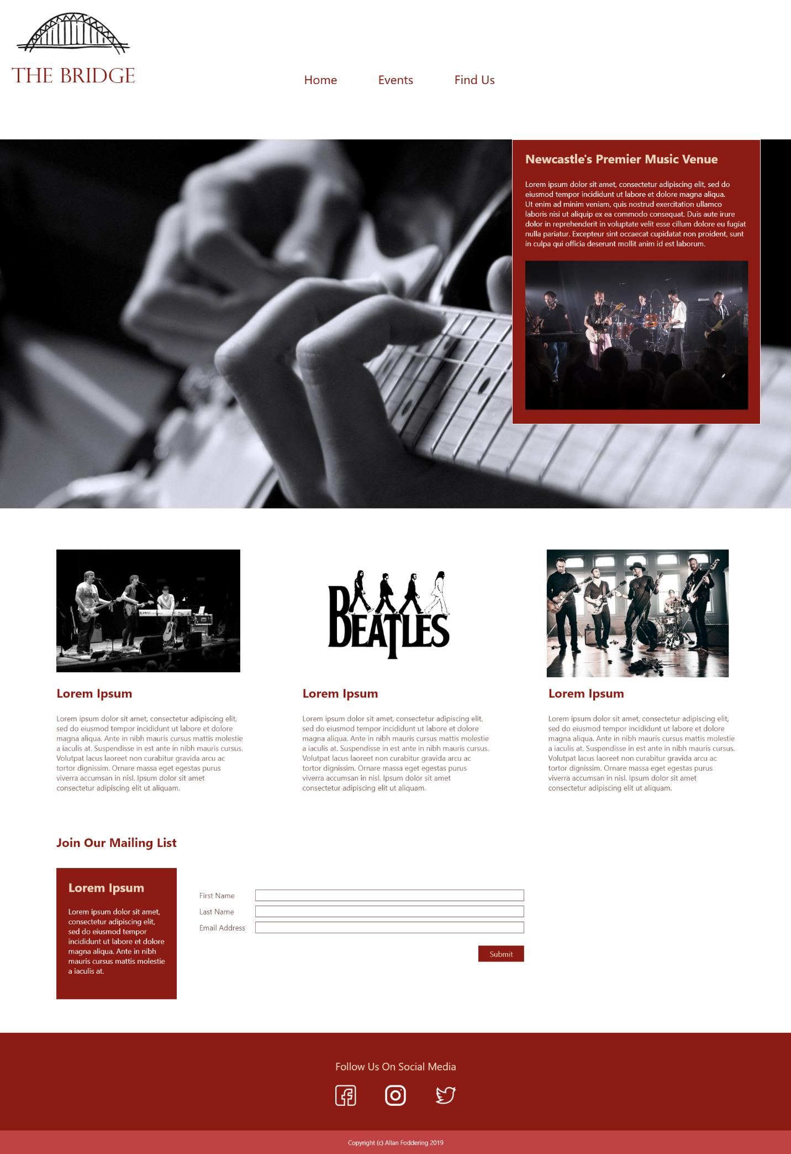

## Figure 23 – Storyboard for the Bridge Homepage

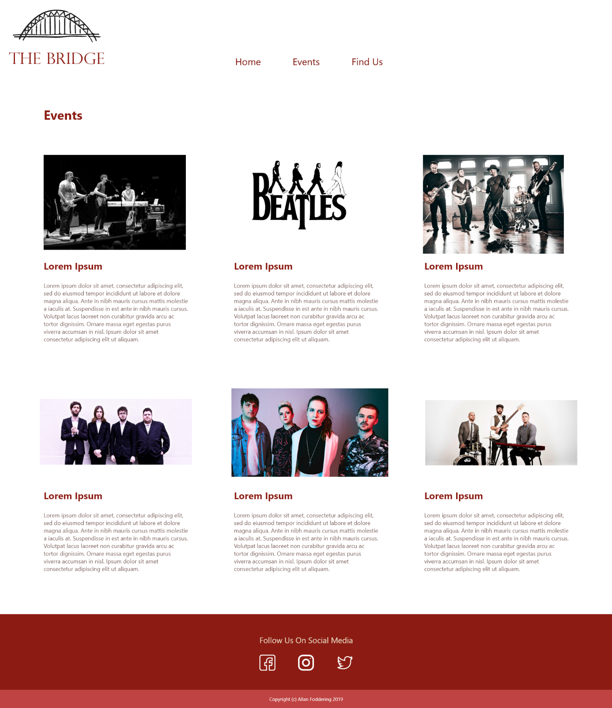

## Figure 24 – Storyboard for the Bridge Events page

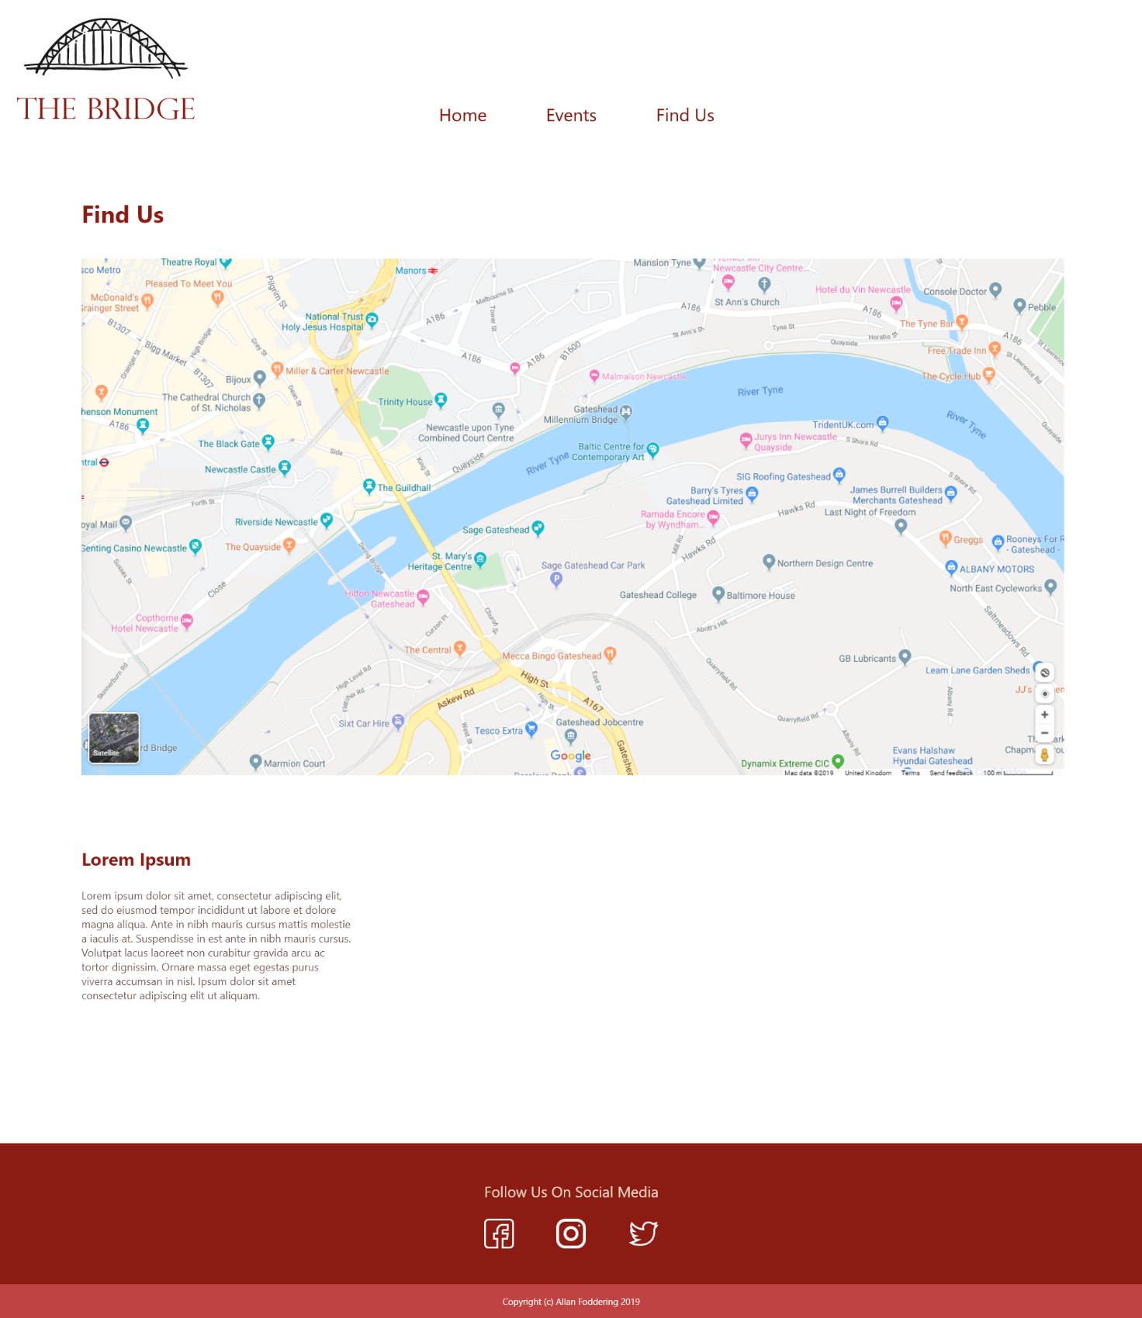

## Figure 25 – Storyboard for the Bridge Find Us page

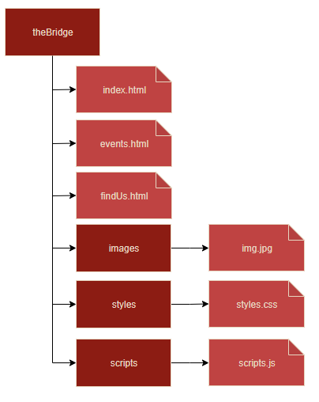

## Figure 26 – the Bridge folder structure

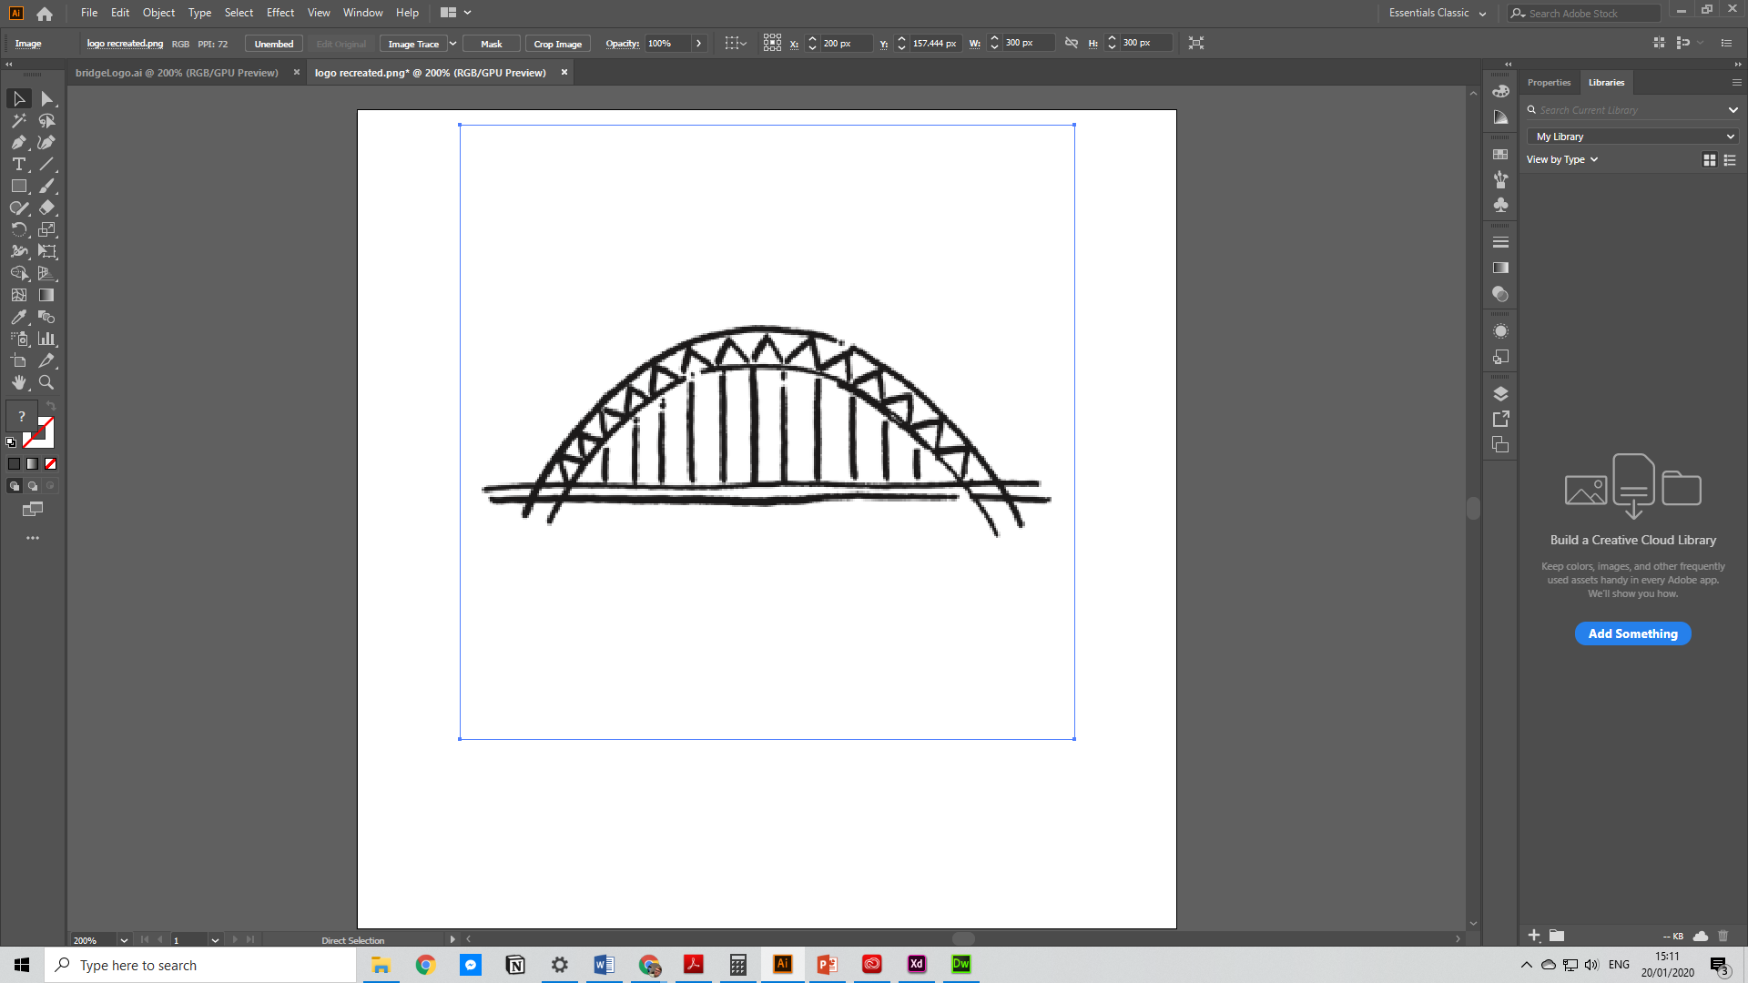

## Figure 27 – Tyne Bridge opened in Adobe Illustrator

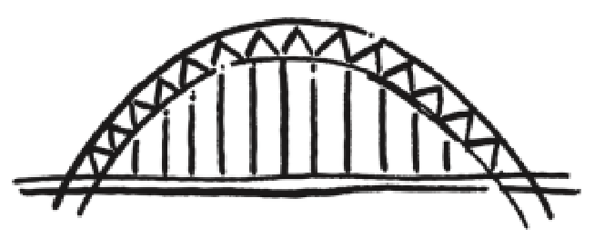

## Figure 28 – Image before tracing and expansion

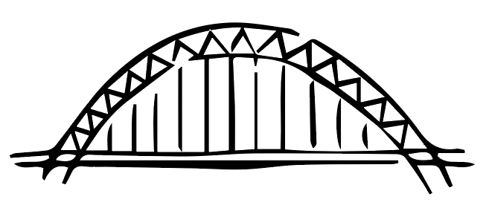

## Figure 29 – Image after tracing and expansion

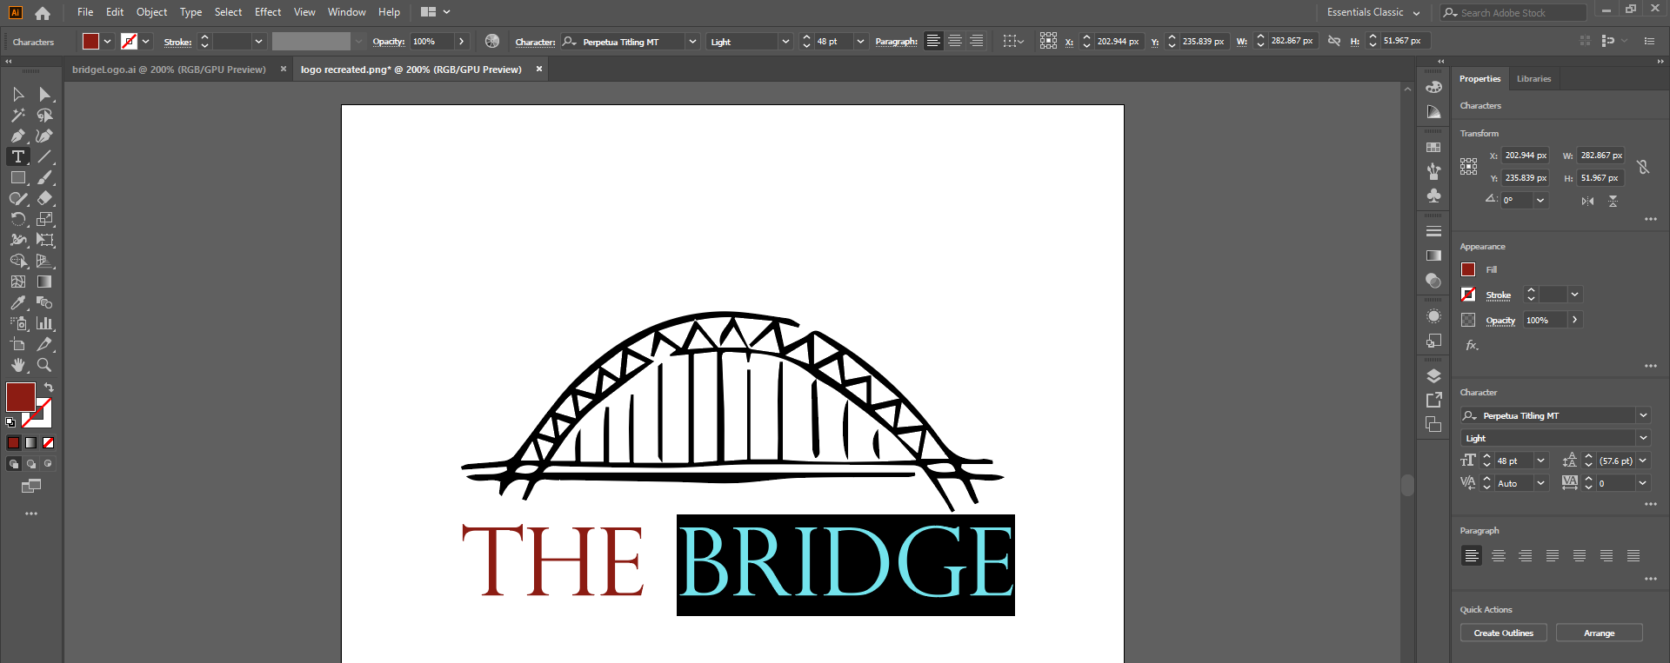

## Figure 30 – Adding text to the logo

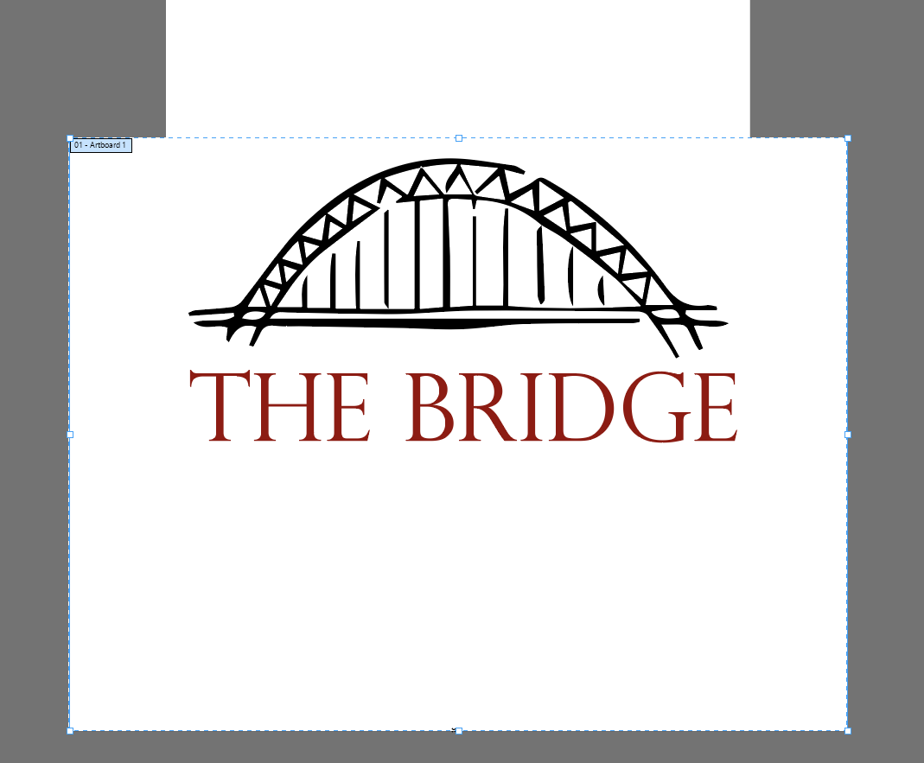

## Figure 31 – Changing the artboard size

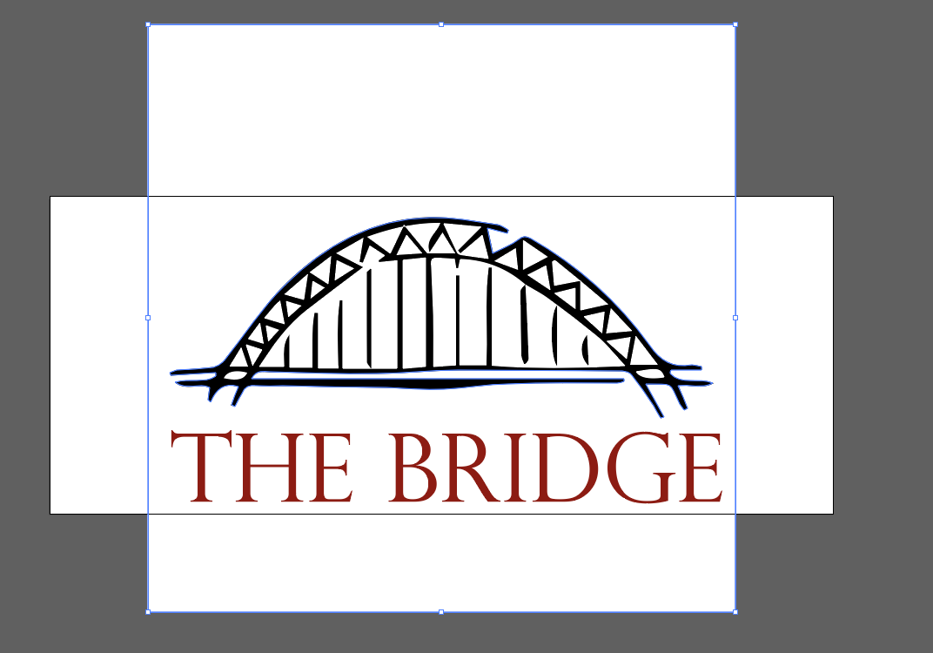

## Figure 32 – Removing the background



## Figure 33 – The finished logo

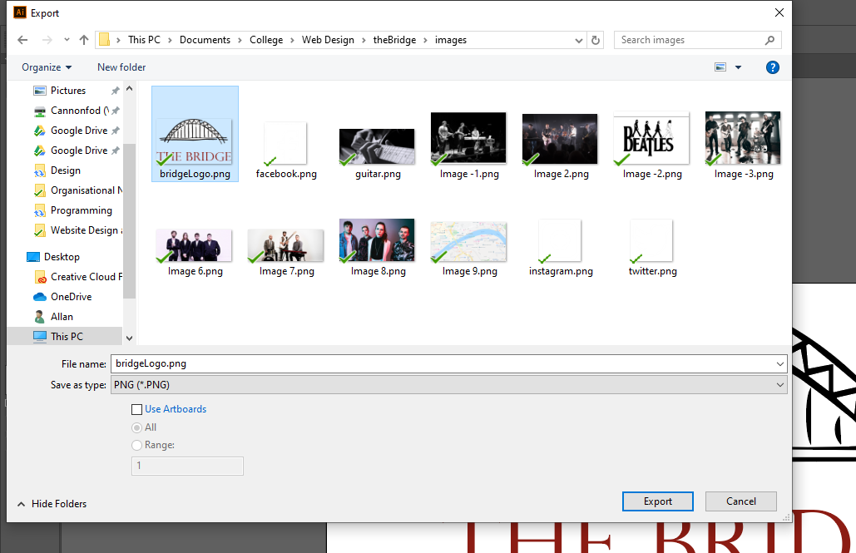

## Figure 34 – Exporting the logo

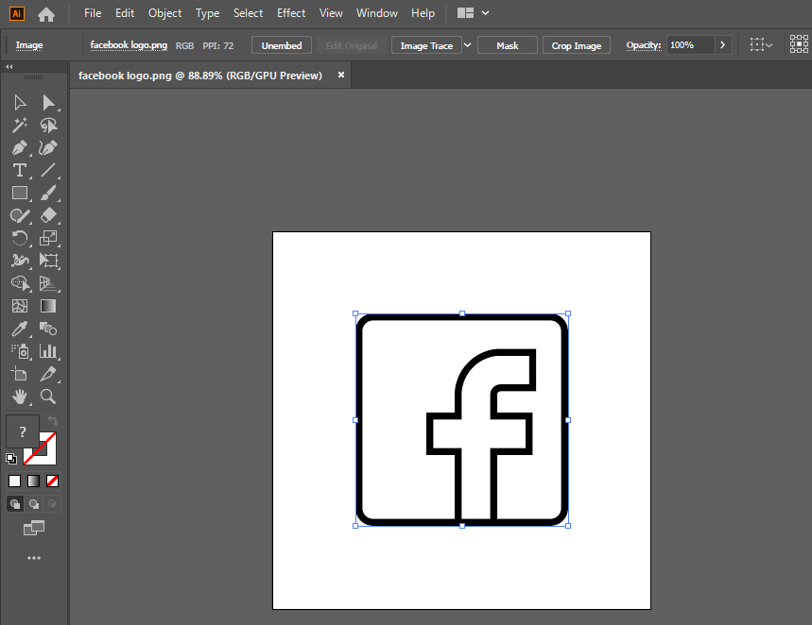

## Figure 35 – Tracing and expanding the image

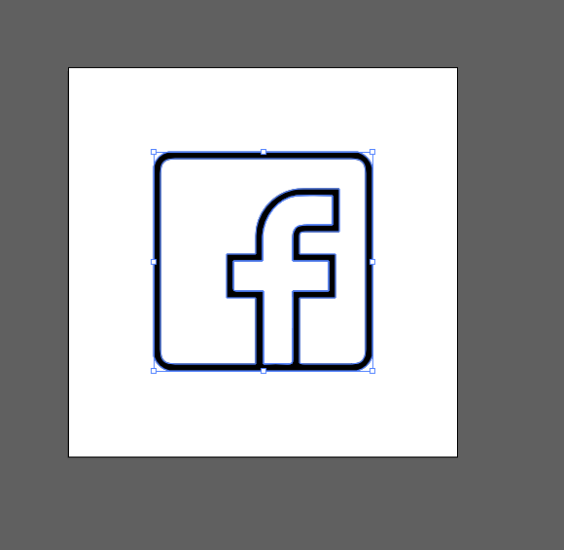

## Figure 36 – Deleting the background

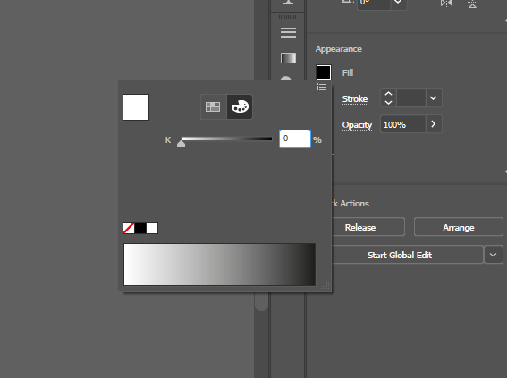

## Figure 37 – Recolouring the logo

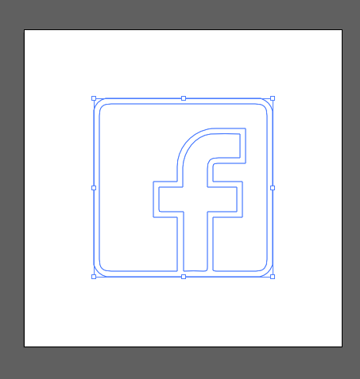

## Figure 38 – The finished recolour

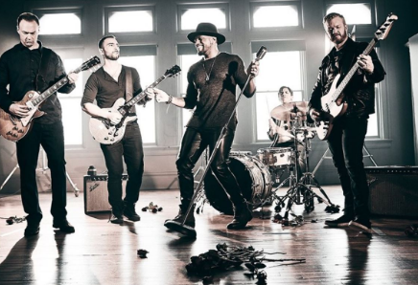

## Figure 39 – The largest image on the first row of the events page

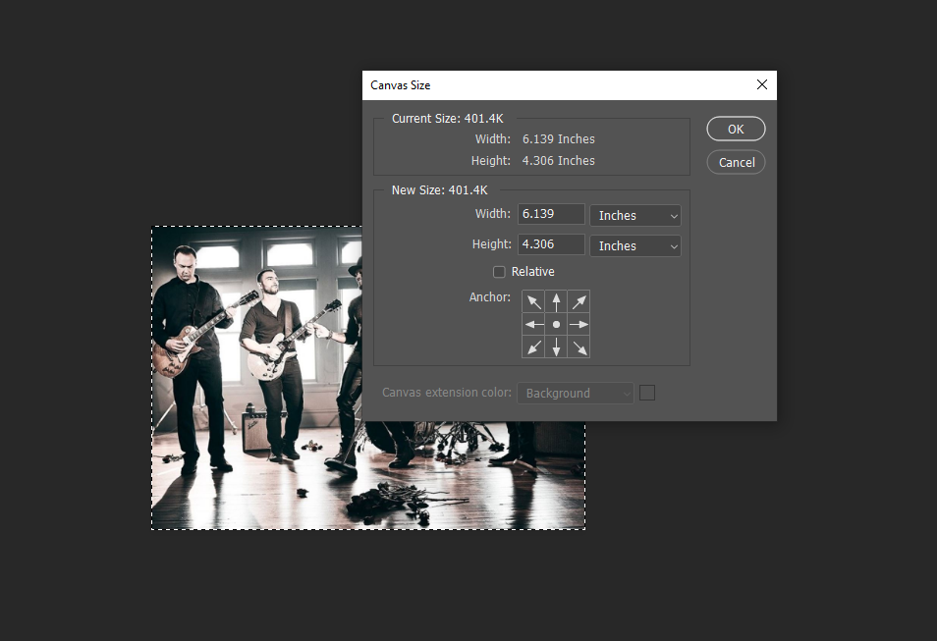

## Figure 40 – Checking the canvas size

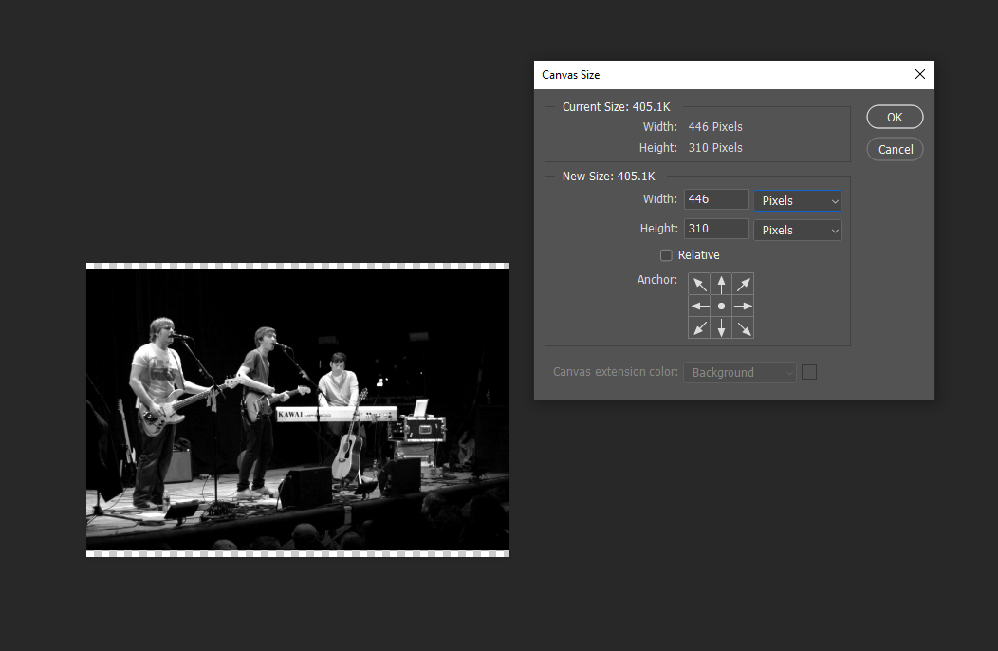

## Figure 41 – Changing the canvas size

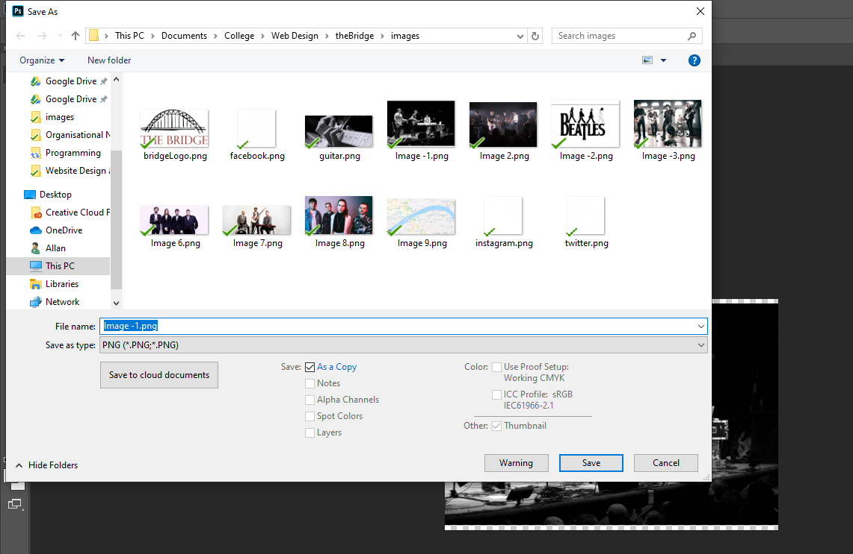

## Figure 42 – Saving the image as a .png

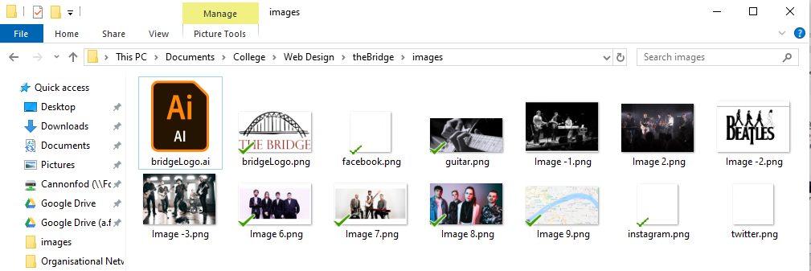

## Figure 43 – The images saved in the file structure

# Reference List

Astra. (2018). *8 Principles of Good Website Design*. [online] Available at: https://wpastra.com/good-website-design/ [Accessed 16 Jan. 2020].

avoleoo (2014). *graf1x.com*. [online] Graf1x.com. Available at: https://graf1x.com/color-psychology-emotion-meaning-poster/ [Accessed 18 Jan. 2020].

Business Website Center (2018). *Can a website have too many colors? | Santa Rosa Website Design*. [online] Santarosawebsite.com. Available at: https://santarosawebsite.com/websitedesign/can-a-website-have-too-many-colors/ [Accessed 17 Jan. 2020].

Digital Marketing Blog. (2019). *11 Important Characteristics of Effective Website Design - LYFE Marketing*. [online] Available at: https://www.lyfemarketing.com/blog/effective-website-design/ [Accessed 16 Jan. 2020].

Digital Next. (2019). *The Importance Of Responsive Web Design | Digital Next*. [online] Available at: https://digitalnext.co.uk/dn-hub/blog/importance-of-responsive-web-design/ [Accessed 17 Jan. 2020].

Fabrikbrands.com. (2017). *Website Colour Schemes: Using Colour In Website Design*. [online] Available at: https://fabrikbrands.com/website-colour-schemes-colour-in-website-design/ [Accessed 17 Jan. 2020].

freeCodeCamp.org (2018). *How Typography Determines Readability: Serif vs. Sans Serif, and How To Combine Fonts.* [online] freeCodeCamp.org. Available at: https://www.freecodecamp.org/news/how-typography-determines-readability-serif-vs-sans-serif-and-how-to-combine-fonts-629a51ad8cce/ [Accessed 18 Jan. 2020].

FreshSparks. (2019). *Why Responsive Design is Important and Google Approved*. [online] Available at: https://freshsparks.com/why-responsive-design-is-important/ [Accessed 17 Jan. 2020].

Krug, S. (2014). *Don’t make me think, revisited : a common sense approach to Web usability*. 3rd ed. Berkeley, Calif.: New Riders.

Lacey Tech Solutions. (2013). *Why is consistency important in Web Design?* [online] Available at: https://laceytechsolutions.co.uk/blog/importance-of-consistency-in-web-design/ [Accessed 17 Jan. 2020].

MDN Web Docs. (2019a). *Dealing with files*. [online] Available at: https://developer.mozilla.org/en-US/docs/Learn/Getting_started_with_the_web/Dealing_with_files [Accessed 20 Jan. 2020].

MDN Web Docs. (2019b). *Dealing with files*. [online] Available at: https://developer.mozilla.org/en-US/docs/Learn/Getting_started_with_the_web/Dealing_with_files [Accessed 20 Jan. 2020].

Optimizely.com. (2019). *Information Scent*. [online] Available at: https://www.optimizely.com/uk/optimization-glossary/information-scent/ [Accessed 17 Jan. 2020].

Shortie Designs. (2018). *Web Design Brisbane | Affordable & Fast Websites | Shortie Designs*. [online] Available at: https://shortiedesigns.com/ [Accessed 16 Jan. 2020].

StatCounter Global Stats. (2019). *Browser Market Share Worldwide | StatCounter Global Stats*. [online] Available at: https://gs.statcounter.com/browser-market-share#monthly-201812-201912-bar [Accessed 17 Jan. 2020].

Testing the Three-Click Rule (2003). *Testing the Three-Click Rule*. [online] UX Articles by UIE. Available at: https://articles.uie.com/three_click_rule/ [Accessed 17 Jan. 2020].

TestLodge Blog. (2016). *Why Cross Browser Testing is Important - TestLodge Blog*. [online] Available at: https://blog.testlodge.com/why-cross-browser-testing-is-important/ [Accessed 17 Jan. 2020].

tictoc digital. (2017). *tictoc digital*. [online] Available at: https://www.tictocdigital.co.uk/latest/46-the-importance-of-colour-in-web-design [Accessed 17 Jan. 2020].

Uptrends.com. (2020). *Website Speed Test | Uptrends*. [online] Available at: https://www.uptrends.com/tools/website-speed-test [Accessed 16 Jan. 2020].

Valentine, L. (2016). *LINGsCARS*. [online] Lingscars.com. Available at: https://www.lingscars.com/ [Accessed 16 Jan. 2020].

Xia, V. (2017). *What is Mobile First Design? Why It’s Important & How To Make It?* [online] Medium. Available at: https://medium.com/@Vincentxia77/what-is-mobile-first-design-why-its-important-how-to-make-it-7d3cf2e29d00 [Accessed 17 Jan. 2020].

Zoltan Gocza, Zoltan Kollin (2019). *Myth #2: All pages should be accessible in 3 clicks - UX Myths*. [online] UX Myths. Available at: https://uxmyths.com/post/654026581/myth-all-pages-should-be-accessible-in-3-clicks [Accessed 17 Jan. 2020].